**SQL Server Project Document sheet**

**Prepare by /**

***1- Ali Abozaid***

***2- Basma Khalaf***

***3- Elham Safwat***

***4- Eslam Waheed***

***5- Hadir Hussien***

**Supervised by / ENG: Sarah Salah**

**ERD**

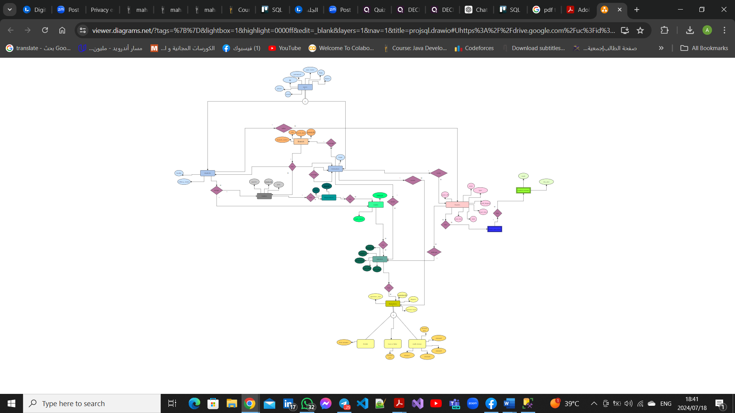

**Mapping**

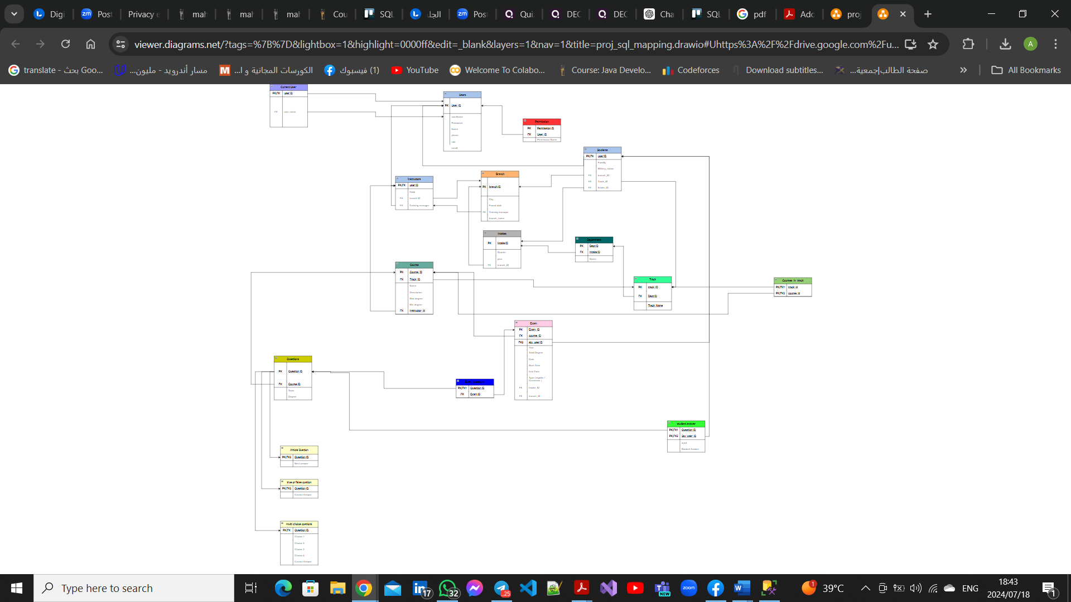

Stored Procedure

|  |  |  |
| --- | --- | --- |
| ***Name*** | ***Stored procedure*** | ***description*** |
| Ali Abozaid | **AddStudent** | * **Stored Procedure to add student in track by training manager** |
| Ali Abozaid | **DeleteStudent** | * **Stored Procedure to delete student by training manager** . |
| Ali Abozaid | **UpdateStudent** | * **Stored Procedure to update student by training manager** |
| Ali Abozaid | **AddIntake:** | **Stored Procedure to add intake by training manager .** |
| Eslam Waheed | **add_instructor** | It inserts a new record into both the users and instructors tables. |
| Eslam Waheed | **update_instructor** | This stored procedure updates the details of an existing instructor in the database. |
| Eslam Waheed | **delete_instructor** | This stored procedure deletes an instructor from the database. |
| Eslam Waheed | **add_track** | It inserts a new record with the provided track ID, department ID, and track name. |
| Elham Safwat | **AddCourseToTrackInBranch** | Stored Procedure For add new course in track in specific branch by training manager  inserts a new record into both Courses; Courses_In_Track. |
| Elham Safwat | **EditCourseInTrack** | Stored Procedure For Update course in track  Update record into both Courses; Courses_In_Track. |
| Elham Safwat | **DeleteCourseFromTrackInBranch** | Stored Procedure For Delete course in track by training manager  Delete record into both Courses; Courses_In_Track. |
| Elham Safwat | **UpdateTrack** | Stored Procedure For Update track  Update record into Track. |
| Hadir Hussien | **Proc_AddInstructorToCourse** | This stored procedure allows training manager to add a new instructor to course. it modifies the courses table. If it isn't a training manager, prints a message indicates that 'Only the Training Manager can add an instructor to a course.' |
| Hadir Hussien | **Proc_UpdateInstructorID** | This stored procedure allows training manager to update a course with a new instructor. it modifies the courses table. If it isn't a training manager, prints a message indicates that 'Only the Training Manager can update the instructor ID.' |
| Hadir Hussien | **Proc_DeleteInstructorID** | This stored procedure deletes an instructor from the course, and make its value is null based on the provided instructor ID. If it isn't a training manager, prints a message indicates that 'Only the Training Manager can delete the instructor ID.' |
| Hadir Hussien | **Proc_GradeExam** | Answers correction |
| Hadir Hussien | **Questions** | Correct the Article, TF and MCQ questions |

Views

|  |  |  |
| --- | --- | --- |
| Ali Abozaid | View All Students | View is designed to view all information about student it selects name, phone, email, Branch name, Track name, Quartur round ,intake year, military status and Faculaty. |
| Ali Abozaid | View all questions for a course: | View to select Question_ID, Question_Text ,Question_Type, degree, Course_ID, Course_Name and Course_Description. |
| Eslam Waheed | view_all_instructors | This view is designed to provide the training manager with an overview of all instructors. |
| Elham Safwat | View_All_Courses | View to provide the Training Manager with all Courses in each Track. |
| Hadir Hussien | View_Tracks | This view is designed to provide the training manager with an overview of all tracks. It selects and displays track_id, dept_id, track,name from the track table. |

Triggers

|  |  |  |
| --- | --- | --- |
| Ali Abozaid | Insert intake | -- Create trigger to prevent instructors from modifying intake |
| Ali Abozaid | Delete intake | -- Create trigger to prevent instructors from modifying intake |
| Ali Abozaid | update intake | -- Create trigger to prevent instructors from modifying intake |
| Eslam Waheed | delete_dpt | This trigger prevents the deletion of a department from the department table. |
| Eslam Waheed | delete_intake | This trigger prevents the deletion of an intake from the intake table. |
| Eslam Waheed | delete_track | This trigger prevents the deletion of a track from the track table. |
| Elham Safwat | trgPreventINST | trigger prevent Instructor from add and update and delete student |
| Hadir Hussien | Trg_PreventStudentAddQuestion | This trigger prevents student to add question to the questions table. Instead of performing the add operation, it prints a message indicates that the action is not allowed for students. |
| Hadir Hussien | Trg_PreventStudentUpdateQuestion | This trigger prevents student to update a question in the questions table. Instead of performing the update operation, it prints a message indicates that the action is not allowed for students. |
| Hadir Hussien | Trg_PreventStudentDeleteQuestion | This trigger prevents student to delete a question from the questions table. Instead of performing the delete operation, it prints a message indicates that the action is not allowed for students. |

**Tables**

|  |  |
| --- | --- |
| Name | Tables |
| Ali Abozaid | Branches |
| Ali Abozaid | Users |
| Elham Safwat | UserRole |
| Elham Safwat | Instructor |
| Elham Safwat | Course |
| Elham Safwat | Course_in_Track |
| Elham Safwat | Student |
| Hadir Hussien | Exam |
| Hadir Hussien | Exam_Questions |
| Hadir Hussien | Student_answer |
| Eslam Waheed | Question |
| Eslam Waheed | TF_question |
| Eslam Waheed | MC_question |
| Eslam Waheed | ART_ question |